Data Analysis and Commentary on Running Training Plan Effectiveness on The Islands
Brad Kreider
Department of Computer, Mathematics, and Physics, Messiah University
April 2026

Abstract
The purpose of this research study is to measure the effect of different structured running plans on subjects’ oxygen uptake (VO₂) within the virtual confines of The Islands. A total of 40 subjects were recruited and randomly assigned across four treatment groups, one of which was a control group. All prescribed running activity was conducted outdoors in order to maintain consistency of the training environment across treatment conditions. Statistical analysis consisted of one-way ANOVA and Tukey’s Test of Multiple Comparisons.

1. Background
The Islands are described as “a virtual human population that has been developed to support learning and teaching in experimental design, epidemiology and statistical reasoning” (University of Queensland). Developed by the University of Queensland, Australia, The Islands offers a virtual environment that is set up to enable realistic research studies on a virtual population and environment. This research study is taking place within the context of The Islands. All subjects are virtual and do not have any real world companions. Any conclusions obtained from this study have no merit or bearing outside of the Islands in the real world. Because the Islands is a virtual and entirely simulated population, there is no formal process for IRB review that is necessary for this study.
Context: A year on the Islands is 28 days long.

2. Motivations
Outside of my academic endeavors as a college student, I also participate in Cross Country and Track & Field at the NCAA Division III level. Thus, I am interested and curious in running and different training styles and metrics. These interests have motivated me to pursue this study on The Islands to study the effects of different running training plans on subjects submaximal oxygen uptake (VO₂ Max).
Question: How do different running training plans affect subjects submaximal oxygen uptake (VO₂ Max) on The Islands?
Expectations: Based upon my real world experience and knowledge of running and aerobic capacity, I would expect to see significant differences between the changes in VO₂ max among the treatment groups.

3. Study Overview
The study will take place over 7 days in the real world, which corresponds to approximately ¼ year on the Islands.

3.1 Recruitment
40 Participants were selected randomly from a randomly selected town on the Islands. (Nelson) Eligible participants were between the ages of 18–55, gender was of no concern.
Homes in Nelson were selected randomly using a random number table. The first eligible participant from each home was selected and asked for consent to be included in the study. If the subject declined to participate or if there were no eligible subjects, the house was passed over.

3.2 Experiment Design
Subjects were placed randomly into 1 of 4 treatment groups. A summary of treatment groups are listed below:
Table 1. Seven-day training protocol by treatment group (n = 10 per group, n = 9 for Maximal after one withdrawal). All runs were conducted outdoors.
Day | Control | Minimal | Moderate | Maximal
1 | Pre-test VO₂ | Pre-test VO₂; 1 km run | Pre-test VO₂; 1 km run | Pre-test VO₂; 5 km run
2 | Rest | Rest | Rest | 5 km run
3 | Rest | 1 km run | 5 km run | 5 km run
4 | Rest | Rest | Rest | 5 km run
5 | Rest | 1 km run | 5 km run | 5 km run
6 | Rest | Rest | Rest | 5 km run
7 | Post-test VO₂ | 1 km run; Post-test VO₂ | 5 km run; Post-test VO₂ | 5 km run; Post-test VO₂

3.3 Tracking
Participant info (name), Pre and post VO₂ measurements, and treatment record (checklist) were recorded in an excel spreadsheet. Please see treatment group 3, “Moderate Running Group” data sheet below.
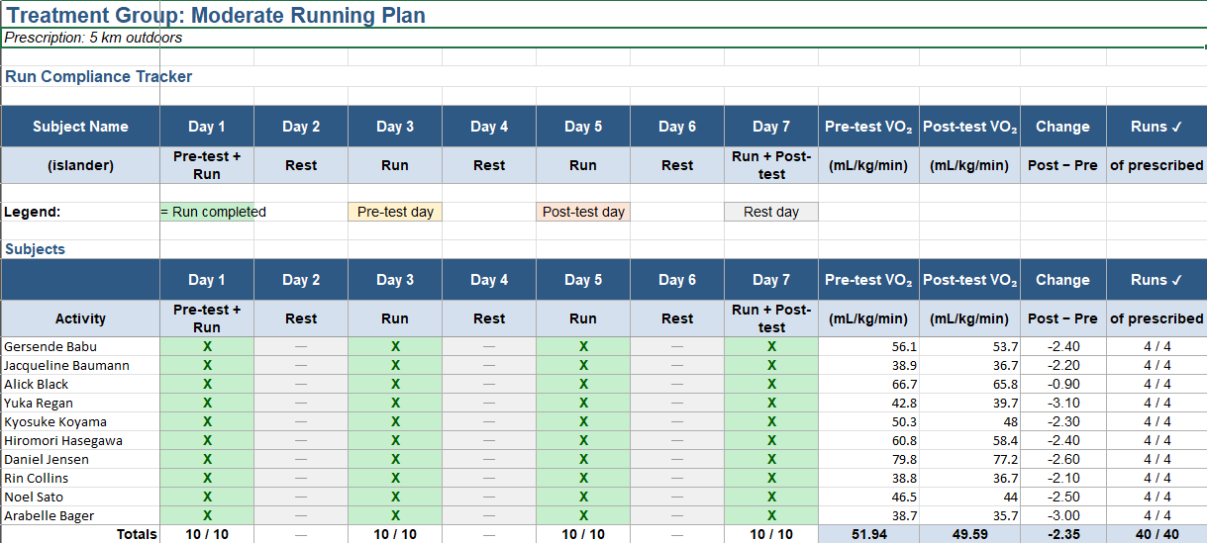
Figure 1. Moderate Running Group tracking sheet.
Data can be obtained at [insert Github link to data here]

Note: On day 3 of the study, one of our subjects in the maximal training group ‘withdrew’ from the study. I received no additional information as to the reason for their withdrawal. Given that we were already 3 days into the study, we proceeded with replacement of another subject. Thus, in our analysis, the maximal training group has 9 participants instead of 10.
All statistical analysis that follows will be made at the 95% confidence level.

3.4 VO₂ Max
“VO₂ max measures how much oxygen your body consumes while exercising” (Warner, 2024). Typically measured in ml/kg/minute, VO₂ max is essentially a measure of how aerobically fit an is. We will be using this metric to track the effectiveness of the treatment group in this study, measured in ml/kg/minute.

4. Analysis
To study the changes in VO₂ max from subject to subject, we will be looking at (post–pre) (VO₂) for each subject. Below are the summary statistics for the 4 treatment groups.
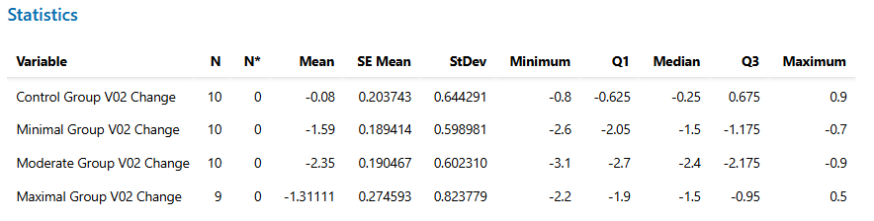
Figure 2. Summary statistics for the four treatment groups.
For our primary analysis of the treatment groups, we will be using a one-way ANOVA test to test for differences in mean VO₂ change for each treatment group.

4.1 Conditions for One-Way ANOVA
For this one way ANOVA test, we need the following conditions to be met:

Independence / Random
We need observations that are independent of one another in our study. In the recruitment of our study, we made use of random sampling to select participants as well as random assignment of treatment groups. Each subject is theoretically independent of one another, as we did not select more than 1 subject per household. The independence condition is satisfied for this study.

Normality
We need our subjects to be sourced from a normally distributed population.
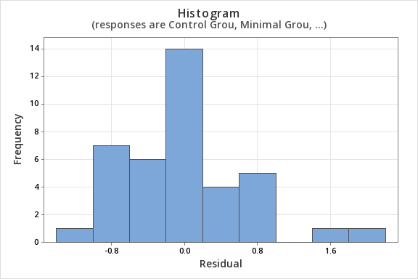
Figure 3. Histogram of residuals vs. frequency.
Looking at our histogram of Residual vs Frequency, we can see that our data somewhat resembles a normal distribution, and appears to be unimodal. However, there appears to be more residual on the right-hand side and the distribution fit is far from perfect. Thus, we will assume the normality condition has been met and will proceed with caution.

Equal Variance
We need our subjects to be sourced from a population with equal variance.
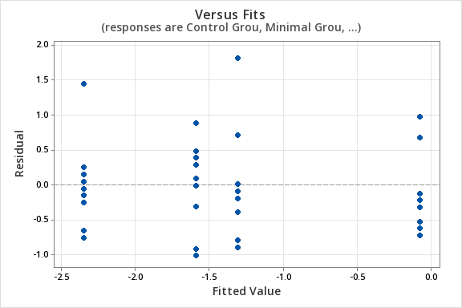
Figure 4. Fitted values vs. residuals.
Looking at the graph of our fitted value vs Residual, we can see that we have fairly scattered residuals for each of our treatment groups, with spread that is roughly equal across the groups. This spread is acceptable to assume equal variance.
Normality is questionable so we will proceed to the ANOVA analysis with caution.

4.2 ANOVA Analysis
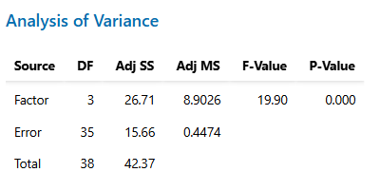
Figure 5. One-way ANOVA output.
Looking at the output for our ANOVA table, it is clear that we have a significant test with F-statistic of 19.9 p-value of approximately 0.000. Thus, we have sufficient evidence to conclude that there exists some difference between the mean differences in VO₂ (post–pre) for all subjects. Our ANOVA test does not inform us as to where these differences come from, so we must turn to a test of Tukey’s Multiple Comparisons to inform us as to where these differences occur.

4.3 Tukey’s Multiple Comparisons
Given the results of our significant ANOVA table, we will run a test of Tukey’s Multiple Comparisons (MC) to locate where exactly these differences occur.
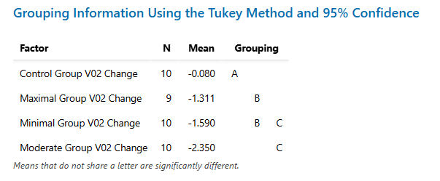
Figure 6. Tukey’s multiple comparisons output.
Looking at the output of our MC test, we gain further insights into the data. It is clear that treatment group #1 (control) displays a significant difference from the other 3 treatment groups, displaying the mean difference in VO₂ (post–pre) closest to 0.
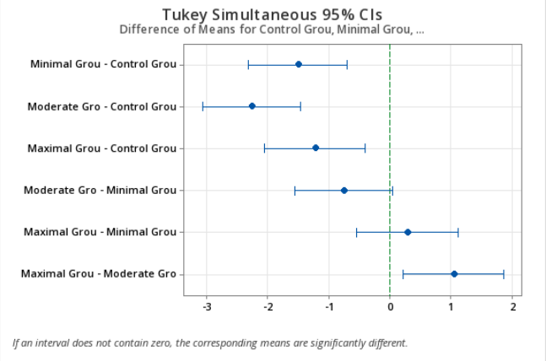
Figure 7. 95% confidence interval plot for the control group.
For the control group, our confidence interval extends on both positive and negative sides of 0. Having a mean difference so close to 0 results in the control group being significantly different (closer to 0) than the other 3 treatment groups.
Tukey’s MC also informs us that the minimal and maximal training plan groups are indistinguishable at the 95% level, along with the moderate and minimal groups.
Formal Tukey’s MC Conclusions:
μ₁ > μ₂, μ₃, μ₄ μ₄ > μ₃

5. Conclusions
Given my interests in running that motivated this study, I would first and foremostly expected all of the treatment groups, with the exception of potentially the control group, to have exhibited positive mean differences in VO₂ (post–pre). In the real world, a running training plan would typically result in a slow increase in submaximal oxygen uptake. Thus, in the Islands, I would have expected to see mean positive differences in the minimal, moderate, and maximal training plan groups, with the maximal training group being the largest difference (increase), the moderate being in the middle, and the minimal being the smallest increase. In terms of the treatment group, I would have expected to have seen VO₂ mean difference be roughly around 0, or potentially slightly negative or positive, but very close to 0 change.
In reality, these expectations were far off of what really took place on the Islands. The control group somewhat met my expectations, resulting in a mean difference of −0.080. Apart from this, my expectations were largely incorrect. Across the various treatment groups that received a running training plan, we saw across the board a decrease (negative mean difference post–pre) in VO₂ max after prescribing a running training plan. Here lies the extent of our statistical analysis. I cannot statistically derive any further conclusions as to why this is the case.

6. Possible Explanations
While I cannot show statistical evidence of any reason for the decrease in mean VO₂ (post–pre) for all the treatment groups, there are some potential confounding factors that could account for this outcome for the Islanders.
- Fatigue. Subjects without a normal habit of running that were thrown into one of the running training plans may have simply become fatigued as a result of the training plan, resulting in a decrease of aerobic capacity at the end of the study.
- Factors of the Islands. Of course, it is also entirely possible that the Islands are simply not set up to account for running being a contributing factor to a subjects VO₂ max. If this were to be the case, no matter how much the subjects ran, their VO₂ max would not be affected.

Appendix A. Formal Six-Step Hypothesis Test
Hypothesis: In this ANOVA Analysis, the null hypothesis assumes that the mean differences in VO₂ (post–pre) for all treatment groups are equal (μ_{i} = μ_{j} ∀ i,j). The alternative hypothesis assumes that the mean differences in VO₂ (post–pre) are not equal in some way (∃ i,j : μ_{i} ≠ μ_{j}). Where μ₁ is the difference in VO₂ (post–pre) for all islanders who would not be on a running treatment plan, μ₂ is the difference in VO₂ (post–pre) for all islanders who would be on a minimal running treatment plan, μ₃ is the difference in VO₂ (post–pre) for all islanders who would be on a moderate running treatment plan, μ₄ is the difference in VO₂ (post–pre) for all islanders who would be on a maximal running treatment plan.
Conditions: The conditions for our ANOVA (Independence, randomness, normality, equal variance) have been satisfied, we are proceeding with caution with the normality condition. See above.
Rejection Region: We will reject H_{O} if TS > 2.87
Test Statistic: TS = 19.90
P-value: p = 0.000
Conclusion: We have enough evidence (p = 0.000) to conclude that the 4 treatments (running training plans) differ with respect to their mean difference in VO₂ (post–pre) for all treatments.

Additional Output
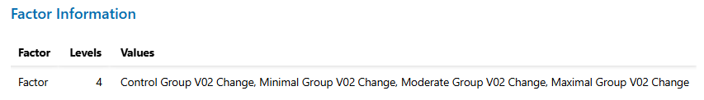
Figure A1. Factor information.
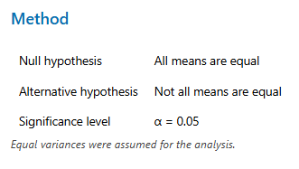
Figure A2. ANOVA method.
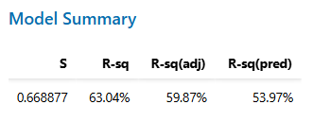
Figure A3. Model summary.
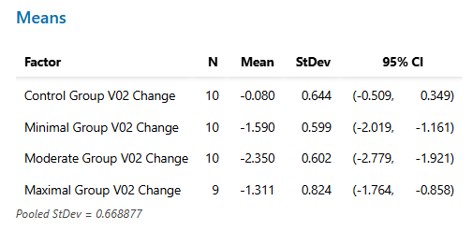
Figure A4. Group means.

References
Minitab, LLC. (2024). Minitab (Version 21) [Software]. https://www.minitab.com
University of Queensland. (n.d.). The Islands: A virtual environment for teaching epidemiology and statistics [Software]. https://islands.smp.uq.edu.au/
Warner, L. (2024, July 8). VO₂ max: What is it and how can you improve it? Harvard Health. https://www.health.harvard.edu/healthy-aging-and-longevity/vo2-max-what-is-it-and-how-can-you-improve-it

